Health Promoting Sports Clubs: Leveraging the Powerful Role of Grassroots Sport to Promote Health

Key message
- Large numbers of participants of all ages meet and train in sports clubs generally under the guidance of a coach. In turn, sports clubs are important settings where health and well-being can be promoted.
- Sport coaches can play a key role to influence participants’ lifestyles but often have limited knowledge and know-how in regard to health promotion.
- Many sporting organisations have a commitment to promote health but need informed and reliable resources and support to help coaches implement these actions.
- National ministries, sport's governing bodies and policymakers at regional and local levels can empower and support stakeholders across sport to promote health.

Why is health promotion in sports clubs needed?
Promoting health in grassroots sports clubs has benefits for multiple sport stakeholders, beyond only sports participants. Having a sports federation, stakeholders and affiliated clubs that care about members’ health helps to enhance sport performance of high-level athletes, foster grassroots sport participation, well-being and enjoyment. This leads to a greater retention of participants, volunteers, coaches and managers, all of whom can be actors in improving long-term health.
The 2007 White paper on Sport published by the European Commission, the Global Physical Activity Plan 2018-2030 and the SHARE 2.0 Initiative Community of Practice have all highlighted the underexploited potential of organised sport to promote health. These statements encourage European member states to support the development of health promotion policies and interventions among sports organisations, as well as stream funding opportunities. Results of the last European Union Physical Activity Policy Monitoring report noted that only a quarter of EU countries have implemented a health promotion programme through organised sport. Similarly, recent results of a survey have shown that only 28% of international sports organisations, which drive national sports federations, integrate health promotion into their strategic objectives and 21% into their missions (https://interact-sport.com/).
On an individual level and at a club level, grassroots coaches are generally competent in their core business, to support the technical and tactical development of their sports participants but are often ill-informed about the underlying health-related aspects of sport. Moreover, coaches, often interact with parents or accompanying persons, which provides additional opportunities for promoting sport and health particularly in youth settings.
In many European countries, there are a good deal of activities and programs in health promoting schools, health promoting cities or workplaces, while grassroots sports clubs have generally been underutilised as a setting for health promotion.
For example, the GAA Healthy Club Project in Ireland has highlighted the socio-economic benefits of health promotion implementation in sports clubs showing a return on investment of 19:1 euros (https://www.gaa.ie/article/irish-life-gaa-healthy-club-programme-a-force-for-good-in-our-communities).
Many benefits of grassroots sports clubs have also been highlighted in numerous scientific studies summarised in Figure 1.
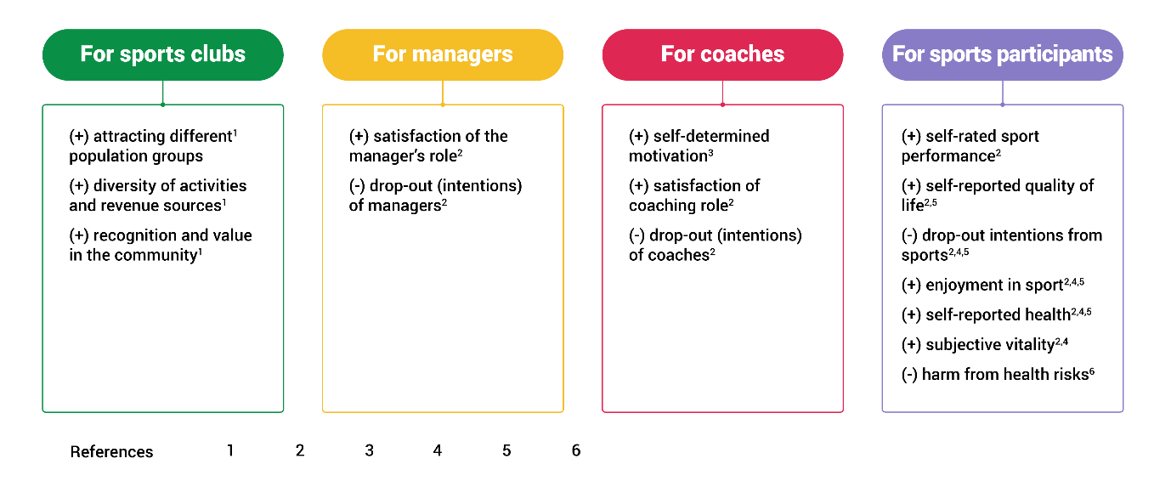
Figure 1. Summary of the benefits of health promoting sports clubs

What is a health promoting sports coach?
A health promoting sports coach is defined as a coach that actively engages with the sports system, utilising its expertise, skills and knowledge to promote health and well-being among sports participants and stakeholders. In the present definition, promoting health is considered as any health topics, encompassing among others health behaviours (nutrition, substance use, injuries), sustainable development (waste management, carbon footprint…), health and physical literacy, human rights, inequities and inequalities (access to sport, use of sport as mean of inclusion and development, good sport governance).

How can national policymakers support sports organisations?
Grassroots sports organisations face multiple barriers when implementing health promotion. Their very nature, often being volunteer-based non-governmental organisations, means they have limited capacity to implement health promotion, lacking human resources, implementation knowledge, funding, as well as external guidance and support. Specific suggestions have been proposed to guide grassroots sports clubs in health promotion, such as the creation of dedicated awareness and training platforms for coaches and managers, as well as the importance of building local or regional networks to reinforce sports organisations’ capacity to promote health. In addition, national sports federations, with their ability to convey and implement national sport policy, could be more oriented towards health promotion, but they often lack guidelines and training.

Why is health promoting coach training an important capacity building opportunity?
A recent study has shown that evidence-driven initiatives implemented among coaches have improved health promotion in sports coaching. Specifically, there have been improvements in coaches’ awareness and knowledge on health promotion and on integrating health promotion content into their coaching practices.
Moreover, research suggests that online training is suitable and effective for sport coaches, offering flexibility and reducing the burden of overinvestment in presence-based approaches.
So far, limited online training is available to educate coaches about health promotion. A case study of existing training offerings has shown that most of the online training is oriented towards a single health behaviour (e.g. injury prevention, physical activity) and does not cover health promotion as a process, limiting the scope of action for coaches.

Conclusions
This policy document shows that national ministries and policymakers have a prominent opportunity to support sports coaches through the provision of online training on health promotion. Through targeted policies, they can support sports federations to deliver training and to provide specific funding for health promotion implementation among the sports movement, based on a high return on investment on such programs.

Recommendations for Action
- Dedicate national-to-local public funding to support or deliver health promotion training to grassroots coaches.
- Nominate at national, regional, local and club levels, a civil servant or delegate who is responsible for health promotion among the sport movement, working across sectors to liaise with stakeholders working on health promotion to support coaches’ health promotion actions.
- Provide resources to sports clubs, including policy, funding streams, guidelines, training, organisational processes, as well as an evaluation system for accountability, to support sports coaches to integrate health promotion into daily coaching.
- Ensure health promotion training is mandatory for initial and continuous coach training.
- Implement a coaching certification system to recognise coaches’ expertise in health promotion, as they move along the coaching pathway.
- Empower sports coaches to reflect on their own health promotion practices, visions and self-management, based on their training skills, habits, public, type of practice and sports discipline.

References
Barros, K., Lefebvre, A., Geidne, S., Bardid, F., Grieco, S., Johnson, S., Kokko, S., Lambe, B., Lane, A., & Ooms, L. (2025). Sports coaches’ perceptions of health promotion: an exploratory study regarding philosophies, actions, barriers, and strategies. HEALTH PROMOTION INTERNATIONAL.
Casey, M., Harvey, J., Eime, R., & Payne, W. (2012). Examining changes in the organisational capacity and sport-related health promotion policies and practices of State Sporting Organizations. Annals of Leisure Research, 15(3), 261-276.
Casey, M., Payne, W., Brown, S., & Eime, R. (2009). Engaging community sport and recreation organisations in population health interventions: Factors affecting the formation, implementation, and institutionalisation of partnerships efforts. Annals of leisure research, 12(2), 129-147.
Commission, E. (2007). White paper: White paper on Sport. Retrieved from http://ec.europa.eu/sport/documents/wp_on_sport_en.pdf
De Leeuw, E. (2009). Evidence for Healthy Cities: reflections on practice, method and theory. HEALTH PROMOTION INTERNATIONAL, 24(suppl 1), i19-i36.
Eckermann, S., McCaffrey, N., Tonmukayakul, U., Swann, C., & Vella, S. (2021). Multiple effects health economic evaluation of the Ahead of The Game Study for mental health promotion in sporting club communities. Health Economics Review, 11(1), 1-15.
Hodder, R. K., O'Brien, K. M., Al-Gobari, M., Flatz, A., Borchard, A., Klerings, I., Clinton-McHarg, T., Kingsland, M., & von Elm, E. (2025). Interventions implemented through sporting organisations for promoting healthy behaviour or improving health outcomes. Cochrane Database of Systematic Reviews(1). https://doi.org/10.1002/14651858.CD012170.pub2
Johnson, S., Van Hoye, A., Donaldson, A., Lemonnier, F., Rostan, F., & Vuillemin, A. (2020). Building health-promoting sports clubs: a participative concept mapping approach. Public Health, 188, 8-17.
Lane, A., Murphy, N., Regan, C., & Callaghan, D. (2021). Health Promoting Sports Club in Practice: A Controlled Evaluation of the GAA Healthy Club Project. INTERNATIONAL JOURNAL OF ENVIRONMENTAL RESEARCH AND PUBLIC HEALTH, 18(9), 4786.
Lee, A., Lo, A., Li, Q., Keung, V., & Kwong, A. (2020). Health Promoting Schools: An Update. Applied health economics and health policy, 1-19.
Lee, A., Lo, A. S. C., Keung, M. W., Kwong, C. M. A., & Wong, K. K. (2019). Effective health promoting school for better health of children and adolescents: indicators for success. BMC PUBLIC HEALTH, 19(1), 1-12.
Meganck, J., Seghers, J., & Scheerder, J. (2016). Exploring strategies to improve the health promotion orientation of Flemish sports clubs. HEALTH PROMOTION INTERNATIONAL, 32(4), 681-690.
World Health Organisation (2018). Global action plan on physical activity 2018–2030: more active people for a healthier world. [Plan].
Pérez-Camarero, J., Martínez-Gallego, R., Francisco Guzmán, J., & Crespo, M. (2022). Online training of sports coaches: bibliographic review. Apunts: Educació Física i Esports(147).
Skille, E. Å. (2011). Sport for all in Scandinavia: sport policy and participation in Norway, Sweden and Denmark. INTERNATIONAL JOURNAL OF SPORT POLICY AND POLITICS, 3(3), 327-339.
Tézier, B., Lucas, Q., Johnson, S., Vuillemin, A., Lemonnier, F., Rostan, F., Guillemin, F., & Van Hoye, A. (2023). A RE-AIM framework analysis of a sports club health promotion MOOC: the PROSCeSS MOOC. HEALTH PROMOTION INTERNATIONAL, 38(4), daad069.
Van Hoye, A., Heuzé, J.-P., Van den Broucke, S., & Sarrazin, P. (2016). Are coaches’ health promotion activities beneficial for sport participants? A multilevel analysis. Journal of science and medicine in sport, 19(12), 1028-1032.
Van Hoye, A., Johnson, S., Geidne, S., & Vuillemin, A. (2020). Relationship between coaches’ health promotion activities, sports experience and health among adults. Health Education Journal, 0017896920919777.
Van Hoye, A., Winand, M., Crochet, L., Simon, F., Rostan, F., Lemonnier, F., Johnson, S., Tezier, B., & Vuillemin, A. (2025). Health promotion in French national sports federations: the challenge of settings-based approach implementation. Global Health Promotion, 17579759251332968.
Whiting, S., Mendes, R., Morais, S. T., Gelius, P., Abu-Omar, K., Nash, L., Rakovac, I., & Breda, J. (2021). Promoting health-enhancing physical activity in Europe: Surveillance, policy development and implementation 2015–2018. Health Policy, 125(8), 1023-1030. https://doi.org/https://doi.org/10.1016/j.healthpol.2021.05.011

